
Troubleshoot Guide

TRINADE AI TECHNOLOGIES PVT.LTD
CONTACT: +96 6559284185

Troubleshoot Guide
Sleep Alert Onboarding Guide
Welcome to the Sleep Alert guide! We are excited to help you improve your lifestyle and wake up while you are feeling Drowsiness while driving vehicles. This guide will walk you through the setup process and explain how to use our sleeping alert device effectively.
Table of Contents
1. Introduction
2. Setup
3. Raspberry pi Installation in your vehicle
4. Account Creation with your credentials (Optional)
5. Setting up the Sleep Alert
6. Using the Sleep Alert
7. Troubleshooting
8. Conclusion

1. Introduction
Sleep Alert is a smart device, It uses gentle sounds and vibrations to gradually wake you up when you are in Drowsiness or sleepy state while driving., ensuring you wake up and take care of properties which will belong to your organization and companies.
Comments:- Please write more details how it works.
2. Setup
Before you can start using the Sleep Alert device, you will need to set it up as per below mention picture. Here are the steps to get started:
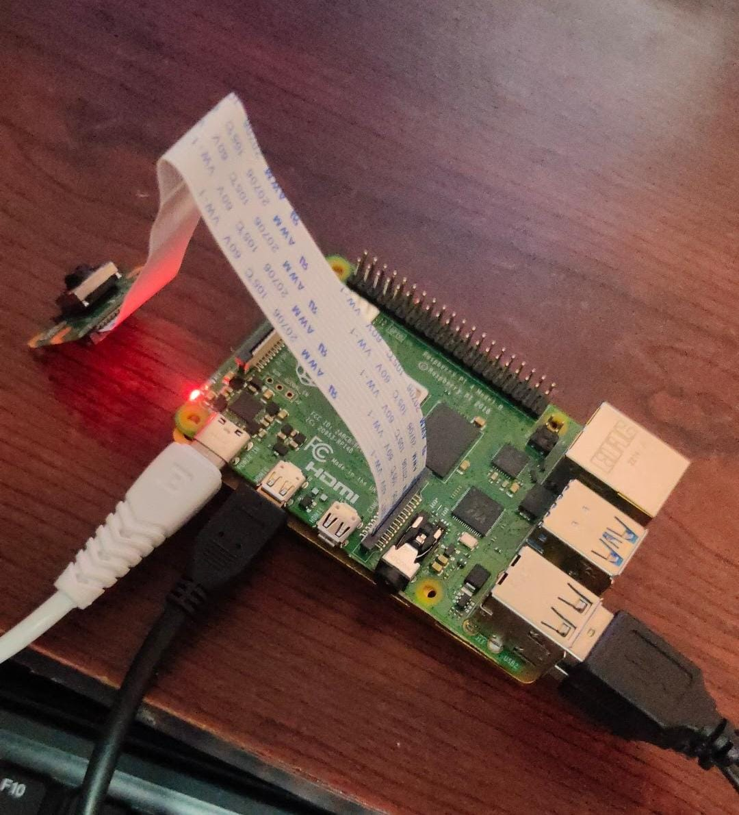
- Connect the Camera Module 3 to Raspberry pi 4, which has the CSI Port.
- If you are willing to connect the display, you will connect DSI port also, you will be able to set the Route Map or Mobile Hotspot as you preferer. (It just like Minicomputer).
- For accessing Raspberry Pi, you will be able to connect using keyboard and Mouse as per your convenience.
- Finally, you need to provide power supply of 5 V or 6 V, via USB Cable to Raspberry pi.

3. Raspberry Pi Installation in Your Vehicle
To begin, Installation of the Sleep Alert device in your vehicles Install the whole setup in Car Cabinet or Truck Cabinet what you received from Trinade. After that, fix the Camera covering 30º to 45º angle of driver. For better understanding read the User Manual. After that switch on the Raspberry Pi, Check the Camera and Raspberry pi is in on/off state. (If you are facing any issue with raspberry pi or Camera, check with Trouble shoot Guide. If the issue is not resolved, contact technical team of Trinade. within 14 days you will receive the Sleep Alert with proper set-up from Trinade. (As per terms Conditions, Privacy& Policy) of Trinade.
5. Setting up the Sleep Alarm and Its working
Now it is time to set up your Sleep Alarm. Follow these steps:
- Switch on the power supply before switching on the device and avoid the loose connections.
- Place the Sleep Alert device on your car cabinet or truck cabinet.
- Follow the Setup Guide for proper running of Raspberry pi
- Check the power supply of Raspberry pi and position of Camera.
- Once connected, you will get an alarm after 5-10 min for 5 sec to make sure the device is working fine. If it is not, then check all connectivity.
- Once your Eyes and Retina are recognized, device will produce an alarm for 15 sec whenever your eyes are closed for 5-10 seconds and make you awake.
- When the alarm does not off until gently you wake up and stop driving, park the vehicle a side or Hand over to another Driver.

6. Using the Sleep Alarm
Using the Sleep Alarm is simple. Just follow these steps:
- Ensure your Sleep Alert device is charged and turned on when you will give the power supply to Raspberry pi.
- When the alarm does not off until gently you wake up and stop driving, park the vehicle a side or Hand over to another Driver.

7. Troubleshooting
- https://1drv.ms/u/s!AgjlUT7mQ7tGfOwqzKR-_G8G_m8
Initially install raspberry pi Imager with new version of OS

- https://www.raspberrypi.com/software/operating-systems/

select the format the Fat32 format – “File Allocation Table.”
Each information in file to host computer.

- Getting trouble with audio jacks while connecting Display to raspberry pi.
- Unable to hear the audio sound.
- Every time getting the problem with OS or raspberry pi.
- Use these commands to update the Raspberry pi.
- sudo apt dist-upgrade
- sudo apt update
- sudo apt upgrade

Note:- Prioritize the steps with fresh Raspbery Pi from installation of Python to implementing the code and then list out what issues you faced in which steps and how did you resolve them.

- Use these commands for installing Python.
- sudo apt install build-essential libssl-dev zlib1g-dev libbz2-dev \
- libreadline-dev libsqlite3-dev wget curl llvm libncurses5-dev libncursesw5-dev \
xz-utils tk-dev libffi-dev liblzma-dev python-openssl
- https://www.python.org/ftp/python/3.11.0/Python-3.11.0.tgz
- . /Configure --enable-optimizations
- tar -xvf Python-3.11.0.tgz
- cd Python-3.11.0
- python3.11 – use this command for check the version of python.
Here list out some new commands for access Camera module 3
- libcamera :- which is the direct command access the camera using cmd prompt.

# Create a PiRGBArray object to store the frames
raw_capture = picamera. array. PiRGBArray (camera, size= (640, 480))#

- File "<string>", line 1, in <module>
File "/home/pi/tensorflow-env/lib/python3.9/site-packages/picamera/__init__.py", line 72, in <module>
from picamera.exc import (
File "/home/pi/tensorflow-env/lib/python3.9/site-packages/picamera/exc.py", line 41, in <module>

- To resolve these issues, re -install the libcamera library.

After running the code unable to play the recorded video , face these types of errors

- v4l2_videodevice.cpp:1047 /dev/video0

- To reslove the issues use these commands:

libavformat-dev libswscale-dev libv4l-dev
sudo apt-get install libxvidcore-dev libx264-dev
sudo apt-get install libfontconfig1-dev libcairo2-dev
sudo apt-get install libgdk-pixbuf2.0-dev libpango1.0-dev
sudo apt-get install libgtk2.0-dev libgtk-3-dev and VLC media player.

Here we are facing the issue with OpenCV lib and Unable to play the video, these errors are facing while run the code using opencv lib and libcamera or Picamera.

- handle Message OpenCV | GStreamer warning: Embedded video playback halted; module v4l2src0 reported: Failed to allocate required memory.
[ WARN:0] global ../modules/videoio/src/cap_gstreamer.cpp (914) open OpenCV | GStreamer warning: unable to start pipeline.

To reslove these issues we use few libraries and some plugins are installed :

- sudo apt install libgstreamer1.0-0
- gstreamer1.0-plugins- base
- gstreamer1.0-plugins-good
- gstreamer1.0-plugins-bad
- gstreamer1.0-plugins-ugly
- gstreamer1.0-libav
- sudo apt-get install build-essential.
- cmake pkg-config libjpeg-dev
- libtiff5-dev libjasper-dev libpng-dev libavcodec-dev libavformat-dev
- libswscale-dev libv4l-dev libxvidcore-dev libx264-dev libgtk-3-dev
- libatlas-base-dev gfortran python3-dev python3-numpy libtbb2 libtbb-
- dev libdc1394-22-dev
After relsove the issue facing another trouble with matplot library:
Matplot is the python library, which used for data visualization, it is comprehensive library that can create variety of plots and charts:
- import subprocess
subprocess. Call (['pip', 'install', 'matplotlib'])
We are trying play live video streaming using the servers:
Plex server and nginx server for live stream
- mmal_xsplitter vout display error: Failed to open Xsplitter:mmal_vout module,
- File "<stdin>", line 1, in <module>
AttributeError: 'NoneType' object has no attribute 'shape'.
- obsensor_stream_channel_v4l2.cpp:138 queryUvcDeviceInfoList ioctl error return: 25
[ERROR:0@0.123] global
- obsensor_uvc_stream_channel.cpp:156 getStreamChannelGroup Camera index out of range
Failed to open the camera.
- File "/home/pi/.local/lib/python3.9/site-packages/picamera/__init__.py", line 72, in <module>
from picamera.exc import ()
Use these commands for access the camera:
- *config.py settings * WEBCAM = True WEBCAM_SRC = 0
- ldconfig -p | grep libmmal

Here we choose the way to run the code and access the camera for continuous video streaming using Machine Learning predefined Algorithms.

- https://1drv.ms/u/s!AgjlUT7mQ7tGgQ5j2zze0yN1d2c
o
- https://1drv.ms/u/s!AgjlUT7mQ7tGgQ_DFslfGTV_tNJz
- Here we use the Cascade classifier is the predefined classifier and use the win sound library and frequency for beeping sound, these cascade classifiers are used for training the several positive (faces or objects) images and arbitrary negative (without faces or object images. By suing these commands able to access the camera and its library
- from picamera2.encoders import H264Encoder
- from picamera2 import Picamera2, Preview
- import time.
- picam2 = Picamera2()
- import subprocess.

- # Replace 'your_audio_file.wav' with the path to your audio file
subprocess. POpen(['omxplayer', '-o', 'local', 'your_audio_file.wav'])
- # Play the sound
channel = sound.play()

- # Wait for the sound to finish
while channel.get_busy():
pygame.time.delay(100)

- pygame.time.wait(int(sound.get_length () * 1000)) # Add this line

Here We are facing some technical errors while run the software on Hardware
- Initially Camera Integration with Raspberry pi, not able to open the preview window and cannot take at least Test.jpeg, Test.hs246 (in the format of Avi., MP4 also.
- We are trying to change the index value of Camera, while start after that avoid the loose connections of Module camera.
- Trying to run the code to access the camera through the sample code
- But failed to access it, while run the code Camera is not responding it need some libraries like python lib and picamera, some kind of libraries.
- After installation of libraries trying to run the code but facing the error “mmal_xsplitter vout display error: Failed to open Xsplitter: mmal_vout module.”

- We are thinking it is OS is not installed successfully, almost reinstall the blue eyes OS around 10 – 15 times, but not get the exact solution.

- Again, create a separate Folder and install the internal missed files, but not get the exact the solution.
- “[ WARN:0] global ../modules/videoio/src/cap_gstreamer.cpp (501) isPipelinePlaying OpenCV | GStreamer warning: GStreamer: pipeline have not been created”
- cv2.imshow('Camera', frame)
cv2.error: OpenCV (4.7.0) /io/opencv/modules/highgui/src/window.cpp:971: error: (-215: Assertion failed) size. width>0 && size. height>0 in function 'imshow'
- Traceback (most recent call last):
File "/home/pi/Desktop/test.py", line 9, in <module>
print (frame. shape)
AttributeError: 'NoneType' object has no attribute 'shape’.
- [ WARN: 0@0.115] global obsensor_stream_channel_v4l2.cpp:138 queryUvcDeviceInfoList ioctl error return: 25
[ERROR:0@0.123] global obsensor_uvc_stream_channel.cpp:156 getStreamChannelGroup Camera index out of range
Failed to open the camera.
- File "/usr/lib/python3.9/ctypes/__init__.py", line 374, in __init__
self._handle = _dlopen(self._name, mode)
OSError: libmmal.so
- After trying one by one line debugging, we are concluding that errors raised by the usage of version of python and some internal libraries etc.

- Camera will be able to access, and it shows the preview window like live streaming, eye cascade and eye classifiers not able to crop the exact the Eye shape and cannot show/ print the open and close eyes images.

General Issue with Sleeping Alert Device and troubleshooting :-

If you encounter any issues with your Sleep Alert, here are a few troubleshooting tips:
- Make sure your device is charged.
- Check that your device is properly connected to the Module 3 Camera.
- Restart your device and try again, detach the USB cable from raspberry pi.
- Do not Remove SD Card or Chip Card from Raspberry Pi.
- If the issue persists, reach out to our customer support team for further assistance or Contact Technical Team of Trinade.

8. Conclusion
Congratulations! You have successfully set up and started using the Sleep Alert. We hope this guide will be helpful in getting you started on your journey to. If you have any further questions or need assistance, contact our technical team.

